Lab Task 04
Zain jabbar (323)
AI (lab)
Q:1
Compute g, h and f values for the first three expansions by hand. Use the supplied campus graph, heuristic, start S and goal G. For each of the first three expansions, write the selected node, g, h and f, plus all remaining frontier entries. Show each arithmetic calculation and explain why the next node is selected. Use successor order and the stated queue tie-breaking consistently
What I did
This code demonstrates **A\*** search by prioritizing nodes using `f = g + h`, where `g` is the cost so far and `h` is the estimated cost to the goal.

- `g` stores the graph’s edges and their costs; `h` stores each node’s estimated distance to `G`.
- `front` is the frontier: each tuple contains `(f, cost_so_far, node)`. At each iteration, the code sorts it and removes the node with the lowest `f`.
- It starts at `S`, then explores `A`, then `C`; their printed `f` values are 5, 5, and 5.
- **There is no syntax error apparent**, but the search is incomplete: it does not check whether the goal has been reached or keep track of the full path.
- The loop also stops after a fixed three iterations, before it removes `G` from the frontier. The optimal route is **S → A → C → G**, with total cost **6**.
- The displayed `Frontier` may not be sorted after adding children, but it is sorted again at the start of the next iteration.
Code screenshot
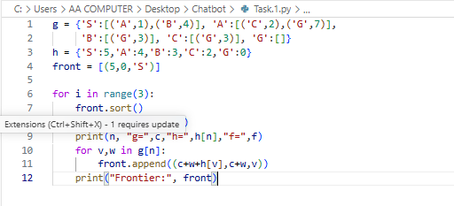
Code Explanation
This code shows the basic idea of **A\* search** for finding a route from **S** to **G**.

- `g` stores the graph: each node’s neighbors and the cost of each edge.
- `h` stores a heuristic estimate of the remaining cost from each node to the goal. For example, `h['G'] = 0` because G is the goal.
- `front` is the list of nodes waiting to be explored. Each tuple is `(f, c, n)`, where `c` is the cost so far, `f = c + h[n]`, and `n` is the node.
- In each of the three iterations, the code sorts `front`, removes the node with the lowest `f`, and prints its values.
- It then adds that node’s neighbors to `front`, calculating each neighbor’s new cost and `f` value.
- This is only a partial A\* demonstration: it doesn’t stop when it reaches G or store the full route, and the three-iteration limit ends before G is explored.

Code Run Screenshot
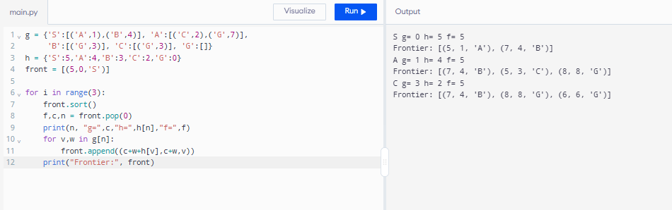
Q:2
Run A* and UCS on the same graph and record expanded nodes. Keep the weighted graph and endpoints identical. Run the supplied heuristic and a zero-heuristic UCS control. Record returned path, independently summed path cost, processed-node trace and expansion count. Use the same counting convention in both runs; explain any stale-entry or goal-counting differences.
What I did
This code compares **A\*** search with **Uniform Cost Search (UCS)** on a weighted graph, looking for a route from **S** to **G**.

- `g` stores the graph connections and their costs; `h` stores estimated costs from each node to the goal.
- `search(H)` uses a priority queue (`heapq`). Each entry contains `(f, cost_so_far, node, path)`, where `f = cost_so_far + H[node]`.
- With `search(h)`, the heuristic helps A\* choose which node to explore. It finds **S → A → C → G**, with total cost **6**.
- With `search({n: 0 for n in h})`, every heuristic is zero, so the priority is just the cost so far; this makes the search UCS. It finds the same route and cost.
- The code also avoids processing a node more than once with `seen`, returns the complete path and cost when it reaches G, and returns `None` if no route is found.
- No error message or earlier version is shown, so I can’t identify a specific error you fixed. Compared with your previous snippet, this version adds a priority queue, full path tracking, a goal check, and a complete search loop.

Code screenshot
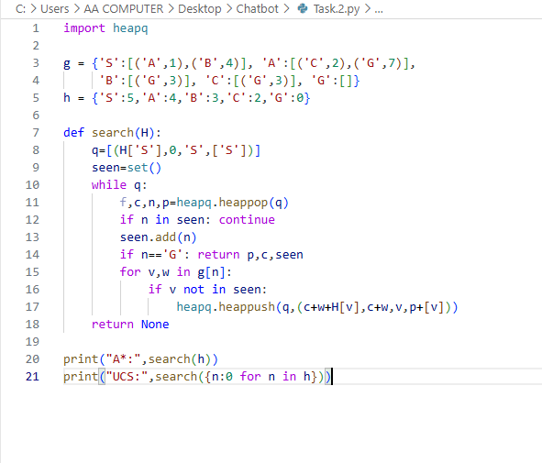
Code Explanation
This code searches for the cheapest route from **S** to **G**, then compares **A\*** with **Uniform Cost Search (UCS)**.

- `g` contains the graph connections and the cost of each edge. For example, moving from `S` to `A` costs `1`.
- `h` gives the estimated remaining cost from each node to `G`. The goal’s estimate is `0`.
- `search(H)` uses a priority queue. Each entry is `(f, c, n, p)`: priority score, cost so far, current node, and path so far.
- For A\*, the priority is `f = c + H[n]`. The function explores the lowest-priority option first, skips nodes already in `seen`, and returns when it reaches `G`.
- `search(h)` runs A\*, which finds **S → A → C → G** with total cost **6**. `search({n: 0 for n in h})` sets every heuristic to zero, so the priority is only the cost so far—that is UCS, and it finds the same cheapest route.
- `seen` is returned along with the path and cost to show which nodes were explored; its printed order may vary because it is a set.

Code Run Screenshot
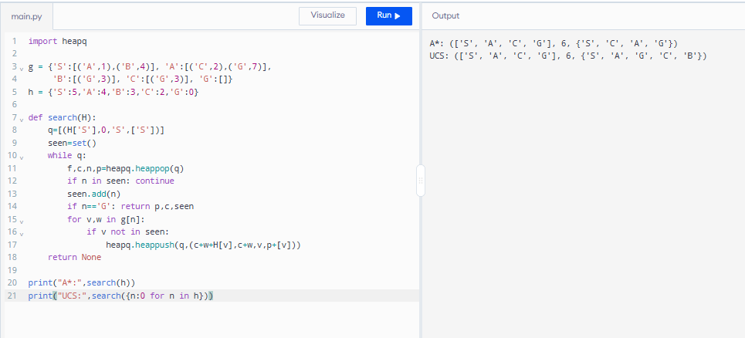
Question 3
Deliberately change one heuristic value to an overestimate and discuss whether the returned result changes. Change one heuristic value only, record its original and modified values, and compare it with that node’s true remaining cost on this small graph. Use h(C)=10 as a reproducible example or justify an equivalent experiment. Rerun, report whether path/cost/count changes, and explain why an overestimate can remove the optimality guarantee even when a particular run appears unchanged

What I did
1. This code runs A* search from **A** to **G**, using a priority queue to choose which route to explore next.
2. Each queue entry contains `(f, g, node, path)`, where `g` is the cost so far and `f = g + h[node]`.
3. `count` records how many nodes are removed from the priority queue before the goal is reached.
4. With all heuristic values set to zero, the search finds **A → C → G**, with cost **4**.
5. After setting `h['C'] = 10`, the heuristic overestimates the actual cost from C to G (which is 2), so A* instead returns **A → B → G**, with cost **6**.
6. There is no Python runtime error; the issue is that this overestimated heuristic makes A* lose its guarantee of finding the cheapest path.

Code Screenshot
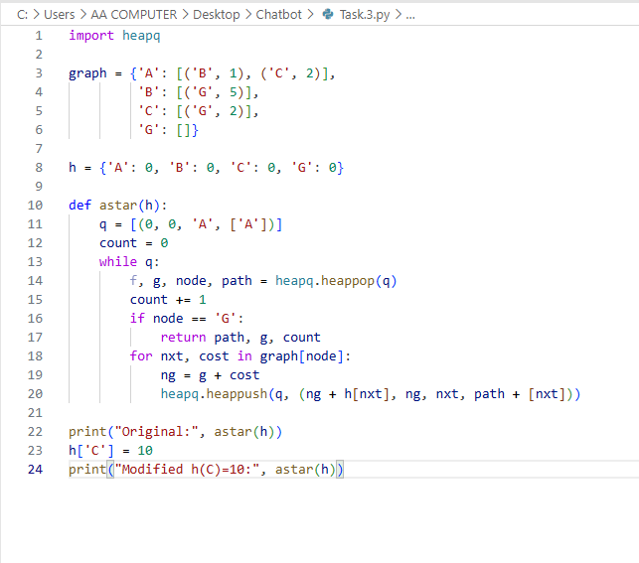
Code Explanation
This code compares how **A\*** search behaves with two different heuristic settings while searching for a route from **A** to **G**.

- `graph` stores each node’s neighbors and the cost of each connecting edge. For example, going from A to C costs 2.
- `h` stores the estimated remaining cost from each node to G. A* calculates a priority score using **`f = g + h`**, where `g` is the cost so far.
- `astar(h)` puts routes into a priority queue (`q`) and explores the route with the lowest `f` value first. Each queue item stores `(f, g, node, path)`.
- `count` increments whenever an item is removed from the queue, including the goal node. The function returns the path, its total cost, and this count when it reaches G.
- With all heuristic values set to zero, it finds **A → C → G**, costing **4**. After `h['C'] = 10`, the estimate for C is too high, so it returns **A → B → G**, costing **6** instead.
- There is no Python error shown; the example illustrates that an overestimated heuristic can make A* miss the cheapest path.

Code Running Screeshot
